會計妹®精品訂購表格 AccGirl ™ Gift Order Form
產品編號  Product No. | 產品名稱  Product Name | 產品款式/顏色  Product Style/Color |  | 價格 (單售)  Price (Ea.) | 優惠價格 (單售)  Special Price (Ea.) | 所需數量  Quantity | 存貨狀況  Inventory Status
文具 Stationary
AGSM0001 | 便利貼 Memo Pad |  |  | HK$5.0 | HK$2.5 | Enter Here | Available
AGSP0001 | 筆袋 Pencil Case | 黃色 Yellow |  | HK$20.0 | HK$10.0 | Enter Here | Available
AGSP0001C | 筆袋(卡通) Pencil Case (Cartoons) | 黃色 Yellow |  | HK$20.0 | HK$10.0 | Enter Here | Available
AGSP0001B | 筆盒(大) Pen Case (Big) | 粉色 Pink |  | HK$15.0 | HK$7.5 | Enter Here | Available
AGSP0001S | 筆盒(細) Pen Case (Small) | 綠色 Green |  | HK$10.0 | HK$5.0 | Enter Here | Available
AGSB0001YL | 文件盒 (A4) Folder Bag | 創業盒 (Starter Kit) | 黃色 Yellow | HK$20.0 | HK$10.0 | Enter Here | Available
AGSB0001RD | 文件盒 (A4) Folder Bag | 會計盒 (Account Kit) | 紅色 Red | HK$30.0 | HK$15.0 | Enter Here | Available
AGSF0001 | 文件夾 (A4) Plastic File |  |  | HK$10.0 | HK$5.0 | Enter Here | Available
AGSP0001PK | 原子筆 (白字)  Pen (White Words) | 粉紅色 Pink |  | HK$4.0 | HK$2.0 | Enter Here | Available
AGSP0001GN | 原子筆 (白字)  Pen (White Words) | 綠色 Green |  | HK$4.0 | HK$2.0 | Enter Here | Available
AGSP0001BL | 原子筆 (白字)  Pen (White Words) | 藍色 Blue |  | HK$4.0 | HK$2.0 | Enter Here | Available
AGSP0001YL | 原子筆 (白字)  Pen (White Words) | 黃色 Yellow |  | HK$4.0 | HK$2.0 | Enter Here | Available
AGSN0001 | 記事本 Notebook |  |  | HK$20.0 | HK$10.0 | Enter Here | Available
手機配件 Mobile Phone Accessories
AGPS0001PKW | 手機支撐貼 Phone Stand Sticker | 桃紅色 (底)  Pink (Background) | 白色 (字)  White (Words) | HK$10.0 | HK$5.0 | Enter Here | Available
AGPS0001PKBK | 手機支撐貼 Phone Stand Sticker | 粉紅色 (底)  Pink (Background) | 黑色 (字)  Black (Words) | HK$10.0 | HK$5.0 | Enter Here | Available
AGPS0001BKW | 手機支撐貼 Phone Stand Sticker | 黑色 (底)  Black (Background) | 白色 (字)  White (Words) | HK$10.0 | HK$5.0 | Enter Here | Available
AGPS0001WBK | 手機支撐貼 Phone Stand Sticker | 白色 (底)  White (Background) | 黑色 (字)  Black (Words) | HK$10.0 | HK$5.0 | Enter Here | Available

會計妹®精品訂購表格 AccGirl ™ Gift Order Form
AGPS0002BW | 手機支撐貼 Phone Stand Sticker | 藍色 (底)  Blue (Background) | 白色 (字)  White (Words) | HK$10.0 | HK$5.0 | Enter Here | Available
AGPS0001SBBK | 手機支撐貼 Phone Stand Sticker | 天藍色 (底)  Sky Blue (Background) | 黑色 (字)  Black (Words) | HK$10.0 | HK$5.0 | Enter Here | Available
AGPS0001PW | 手機支撐貼 Phone Stand Sticker | 紫色 (底)  Purple (Background) | 白色 (字)  White (Words) | HK$10.0 | HK$5.0 | Enter Here | Available
AGPS0001YW | 手機支撐貼 Phone Stand Sticker | 黃色 (底)  Yellow (Background) | 白色 (字)  White (Words) | HK$10.0 | HK$5.0 | Enter Here | Available
AGPS0001RW | 手機支撐貼 Phone Stand Sticker | 紅色 (底)  Red (Background) | 白色 (字)  White (Words) | HK$10.0 | HK$5.0 | Enter Here | Available
AGPS0001OBK | 手機支撐貼 Phone Stand Sticker | 橙色 (底)  Orange (Background) | 黑色 (字)  Black (Words) | HK$10.0 | HK$5.0 | Enter Here | Available
AGPS0001GBK | 手機支撐貼 Phone Stand Sticker | 綠色 (底)  Green (Background) | 黑色 (字)  Black (Words) | HK$10.0 | HK$5.0 | Enter Here | Available
AGPC0001OR | 手機殼 Phone Case | 原色 (型號: IPhone 6,6s,7,7s,8,8s)  Original (Model: IPhone 6,6s,7,7s,8,8s) |  | HK$100.0 | HK$50.0 | Enter Here | Available
AGPC0001NO | 手機殼 Phone Case | 夜光 (型號: IPhone 6,6s,7,7s,8,8s)  Noctilucent (Model: IPhone 6,6s,7,7s,8,8s) |  | HK$140.0 | HK$70.0 | Enter Here | Available
AGAIP0001 | iPad套 iPad Case (19 x 24cm) | 黃色 Yellow |  | HK$100.0 | HK$50.0 | Enter Here | Available
其它 Others
AGOB0001YR | 環保袋 Eco Bag | 黃色 (底)  Yellow (Background) | 紅色 (字)  Red (Words) | HK$40.0 | HK$20.0 | Enter Here | Available
AGOB0001AO | 環保袋 Eco Bag | 杏色 (底)  Almond (Background) | 橙色 (字)  Orange (Words) | HK$40.0 | HK$20.0 | Enter Here | Available
AGOB0001OA | 環保袋 Eco Bag | 橙色 (底)  Orange (Background) | 杏色 (字)  Almond (Words) | HK$40.0 | HK$20.0 | Enter Here | Available
AGOB0001CMWR | 環保袋 Eco Bag | 米黃色 (底)  Cream (Background) | 酒紅色 (字)  Wine Red (Words) | HK$40.0 | HK$20.0 | Enter Here | Available
AGOB0001BKPK | 環保袋 Eco Bag | 黑色 (底)  Black (Background) | 桃紅色 (字)  Pink (Words) | HK$40.0 | HK$20.0 | Enter Here | Available

會計妹®精品訂購表格 AccGirl ™ Gift Order Form
AGOB0001BR | 環保袋 Eco Bag | 藍色 (底)  Blue (Background) | 紅色 (字)  Red (Words) | HK$40.0 | HK$20.0 | Enter Here | Available
AGOB0001GDG | 環保袋 Eco Bag | 淡灰色 (底)  Grey (Background) | 深灰色 (字)  Dark Grey (Words) | HK$40.0 | HK$20.0 | Enter Here | Available
AGOB0001BDB | 環保袋 Eco Bag | 淡啡色 (底)  Brown (Background) | 深啡色 (字)  Dark Brown (Words) | HK$40.0 | HK$20.0 | Enter Here | Available
AGOB0001PEB | 便擕環保袋Portable Eco Bag |  |  | HK$15.0 | HK$7.5 | Enter Here | Available
AGOS0001 | 創業龍公仔  Start Up Dragon Furry Doll |  |  | HK$168.0 | HK$88.0 | Enter Here | Available
AGOS0001M | 創業龍公仔(迷你牌)  Start Up Dragon Furry Doll(Mini) |  |  | HK$58.0 | HK$38.0 | Enter Here | Available
AGOF0001 | 扇 Fan |  |  | HK$5.0 | HK$2.5 | Enter Here | Available
AGOBO0001GD | 開瓶器 (白字)  Bottle Opener (White Words) | 金色 Golden |  | HK$10.0 | HK$5.0 | Enter Here | Available
AGOBO0001G | 開瓶器 (白字)  Bottle Opener (White Words) | 綠色 Green |  | HK$10.0 | HK$5.0 | Enter Here | Available
AGOBO0001B | 開瓶器 (白字)  Bottle Opener (White Words) | 藍色 Blue |  | HK$10.0 | HK$5.0 | Enter Here | Available
AGOBO0001R | 開瓶器 (白字)  Bottle Opener (White Words) | 紅色 Red |  | HK$10.0 | HK$5.0 | Enter Here | Available
AGOBO0001P | 開瓶器 (白字)  Bottle Opener (White Words) | 紫色 Purple |  | HK$10.0 | HK$5.0 | Enter Here | Available
AGOC0001SPK | Cap帽 Baseball Cap | 銀色 (底)  Silver (Background) | 桃紅色 (字)  Pink (Words) | HK$200.0 | HK$200.0 | Enter Here | Out-of-stock
AGOT0001BKPK | T恤 T-shirt | 黑色 (底)  Black (Background) | 桃紅色 (字)  Pink (Words) | HK$200.0 | HK$200.0 | Enter Here | Out-of-stock
AGOC0001 | 一週年紀念漫畫冊 Picture Book |  |  | HK$20.0 | HK$20.0 | Enter Here | Available

客戶資訊 Client Information
申請人稱號  Applicant Name: | Mr. / Ms. | 聯絡號碼  Contact No.: | Enter Here | 電郵  E-mail: | Enter Here
寄件地址  Shipping Address: | Enter Here |  |  | 運送方式  Shipping Method: | Select Shipping Method
申請人簽署  Signature: | ____________________ | 日期  Date: | Select Date | 總額  Total Amount: | Enter Here
下單流程 Order Procedure
填妥訂購表格後電郵已簽署的表格 (掃描本) 到 enquiry@accgirl.com 。如有任何查詢，請致電 +852 3465 9888 或電郵 enquiry@accgirl.com 與會計妹®職員聯絡。
Send us a scanned copy of the completed (and signed) gift order form via email at enquiry@accgirl.com. Please contact AccGirl™ staff at +852 3465 9888 or email us at enquiry@accgirl.com if you have any further queries.

會計妹®精品參考圖片 AccGirl ™Product Images
文件盒 (A4) Folder Bag  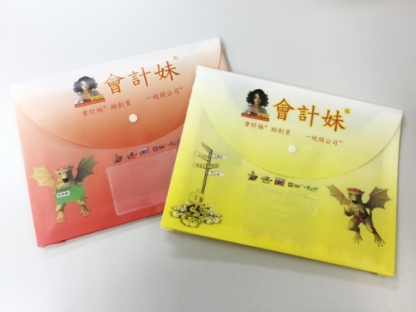 | 文件夾 (A4) Plastic File  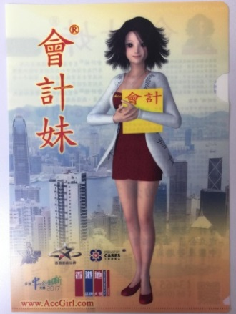 | iPad套 iPad Case (19 x 24cm)  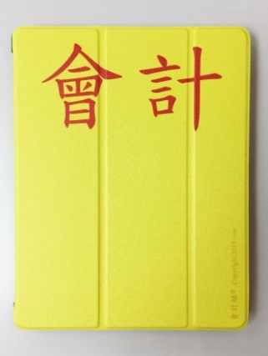 | 扇 Fan  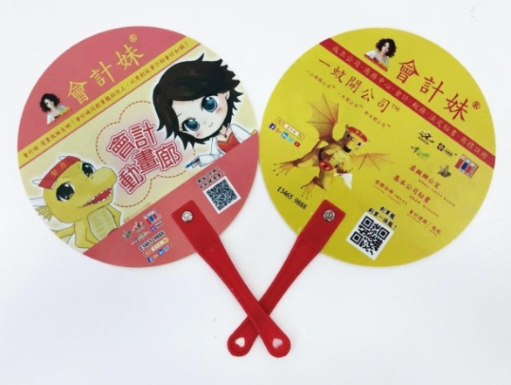
創業龍公仔 Start Up Dragon Furry Doll |  | 創業龍公仔(迷你牌)Start Up Dragon Furry Doll(Mini)

會計妹®精品參考圖片 AccGirl ™Product Images
便利貼 Memo Pad  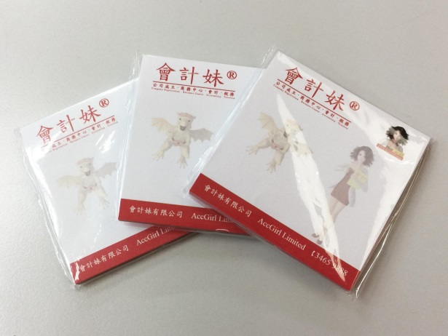 | 手機支撐貼 Phone Stand Sticker  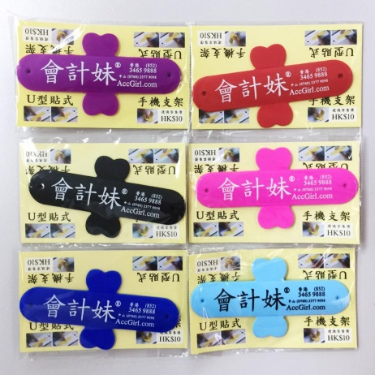 |  | 原子筆 (白字) Pen (White Words)  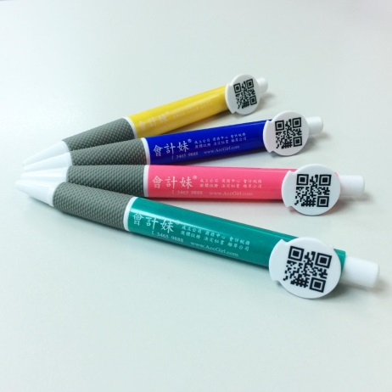 |  | 手機殼 Phone Case  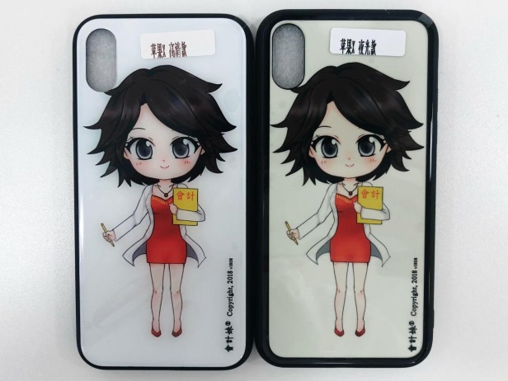
開瓶器 (白字) Bottle Opener (White Words)  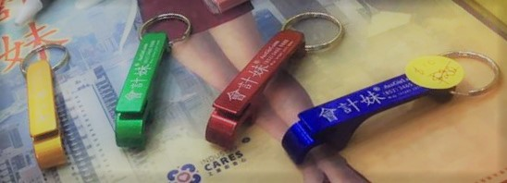 |  | 環保袋 Eco Bag  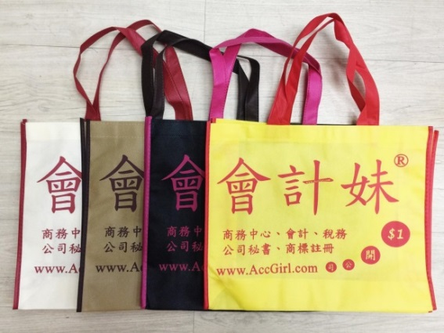 |  | 環保袋 Eco Bag  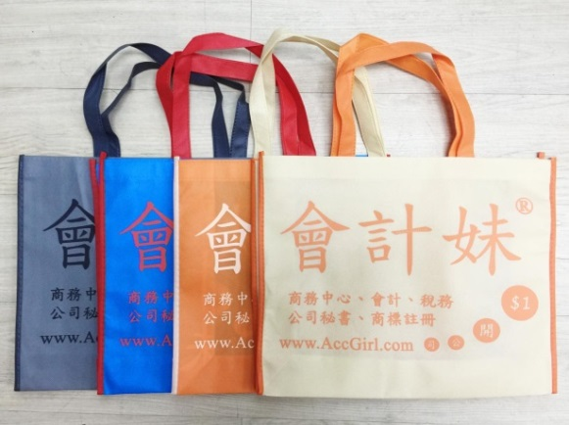

會計妹®精品參考圖片 AccGirl ™Product Images
筆袋(卡通) Pencil Case (Cartoons) | 筆袋 Pencil Case |  | 筆盒(細) Pen Case (Big) |  | 筆盒(細) Pen Case (Small)
便擕環保袋Portable Eco Bag |  | 一週年紀念漫畫冊 Picture Book |  | 記事本 Notebook

